Using Dispatch Report on TMA Dashboard V2.4

1. Go to: <https://info.tmagrain.com>
2. TMA employees login to this program is the same login that is used to login to your PC. Other coops request your login by clicking the “Request Dashboard Account” link under the login.

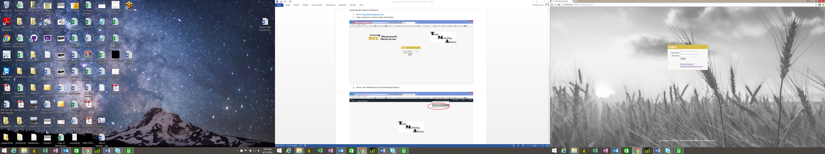

1. When requesting your account login, enter your first name, last name, email address, location and click the “Submit” button. Your account login will be emailed to you within a few minutes. Go back to [https://info.tmagrain.com](http://info.tmagrain.com) and login.

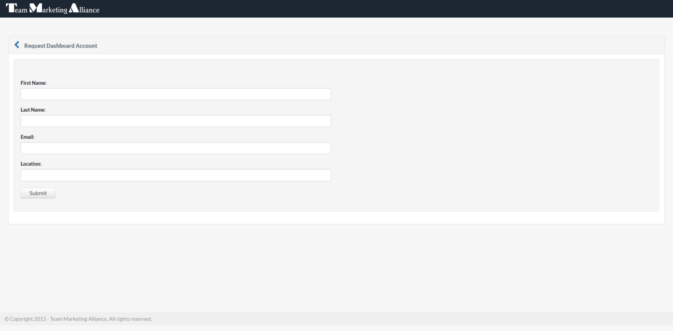

1. Once you have logged in successfully, your home page will look like this:

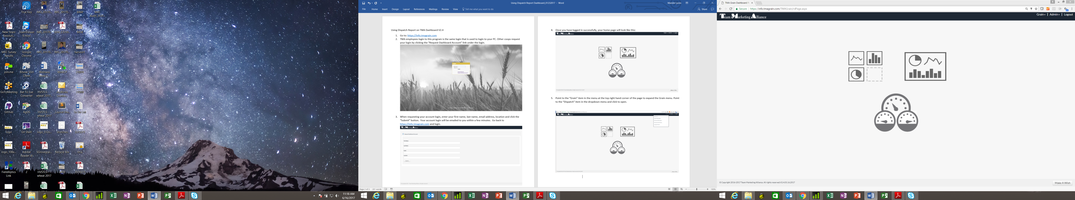

1. Point to the “Grain” item in the menu at the top right hand corner of the page to expand the Grain menu. Point to the “Dispatch” item in the dropdown menu and click to open.

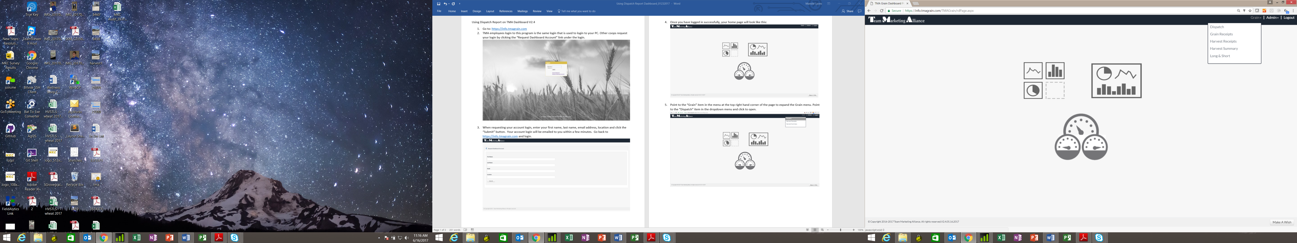

1. Point to the “Dispatch” item in the dropdown menu and click to open.

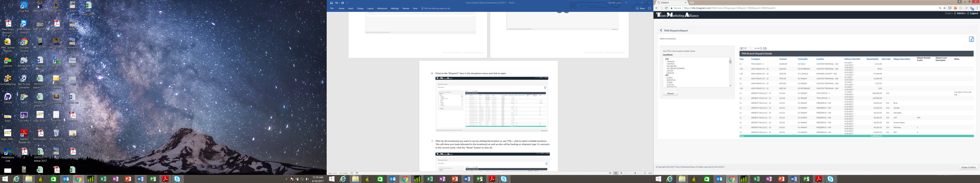

1. Filter by the location(s) you want to see by clicking the location or use CTRL + click to select multiple locations. This will show you loads allocated to the location(s) as well as who will be hauling on shipment type 11 contracts in the current week. Click the “Reset” button to view all.

To download to Excel, click the Excel icon at the top right corner just above the Dispatch Details.

